Brain Breaks: Follow the different cards below for some fun physical activities to get your body moving. They are made to be chosen at random and only take a few minuets each to do.
Brain Break: 5,4,3,2,1

Brain Break Instructions: In this simple game, students stand up and the teacher has them do five different movements in descending order. For example the teacher would say: “Do five jumping jacks, spin around four times, hop on one foot three times, walk all the way around the playroom two times, give your neighbour one high-five (pausing in between each task for students to do it)

Brain Break: Six Spots

Brain Break Instructions: Number six spots around your room from 1-6. Have children each go to a spot of their choice. Choose a child to roll a die. All the children at the number rolled must go back to their seats. Children that are left go to a new spot, and the die is rolled again. Continue until only a few students are left.

Brain Break: Mingle, Mingle, Group

Brain Break Instructions:In this game students mill about the classroom saying, “mingle, mingle, mingle” in
soft voices until the teacher says, “Groups of 5,” at which point the students must quickly group themselves into groups with the correct number of people. Students who are left over must do three jumping jacks before the next round starts. The teacher can call out any number for the group size. You can also add rules such as: as soon as a group is complete, all members must sit down in a line

Brain Break: Freeze Dance

Brain Break Instructions: Similar to Dance Party, except that every so often the music stops, and students must freeze and hold the position they are in until the music begins again.

Brain Break: Simon Says – An oldie but a goody!

Brain Break: Animal Pretend

Animal Pretend Instructions: pretend to be various animals (or even objects such as lawn mowers or airplanes). Call out a few insequence.

Brain Break: Find it Fast

- Find it Fast Instructions: Call out a color or other trait (e.g. something round, something made of wood), and students must find an object in the room that fits the trait and get to it quickly.

Brain Break: Physical Challenges

Physical Challenges Instructions: Challenge students to do something physically difficult, such as standing on one foot with arms extended, or this one: Grab your nose with left hand, and grab your left earlobe with your right hand, and then quickly switch so that your right hand is on your nose and your left hand is grabbing your right earlobe. Yoga poses could also be a good variation.

Find it Fast Instructions: Call out a color or other trait (e.g. something round, something made of wood), and students must find an object in the room that fits the trait and get to it quickly.

Brain Break: Line Up

Line Up Instructions: Children to line up and follow the leader , crawl under chair legs and around the room.

Brain Break: Body Roll Ups

Body Roll Ups Instructions: Children lay on their back with arms overhead and roll over, then get up sit to stand.

Brain Break: Name Game

Name Game Instructions: Children ‘s names are used to create action sequences from the name game chart. (sheet provided at end of document)

Brain Break: Wheelbarrow Walks

Wheelbarrow Walks Instructions: Children ‘s names are used to create action sequences from the name game chart.

Brain Break: Qi Gong Tapping Exercise

Qi Gong Tapping Exercise Instructions: Start by holding lower stomach, then patting up from stomach move up to chest, move to left arm with hand upturned to ceiling, tap from chest to armpit, down arm, to fingertips, clapping hands in middle, go back up arm with arm turned back, tap along back to chest, swap hands and do the same with right hand/arm. Tap face in 3 areas, Fists on head (Gently tapping over head towards neck) Hands on lower back at kidneys, tap down legs at back to ankles, then come around the front of legs and come back up. Hold lower stomach (eyes closed) take 3 breaths in and out through hands, open eyes / shake a little

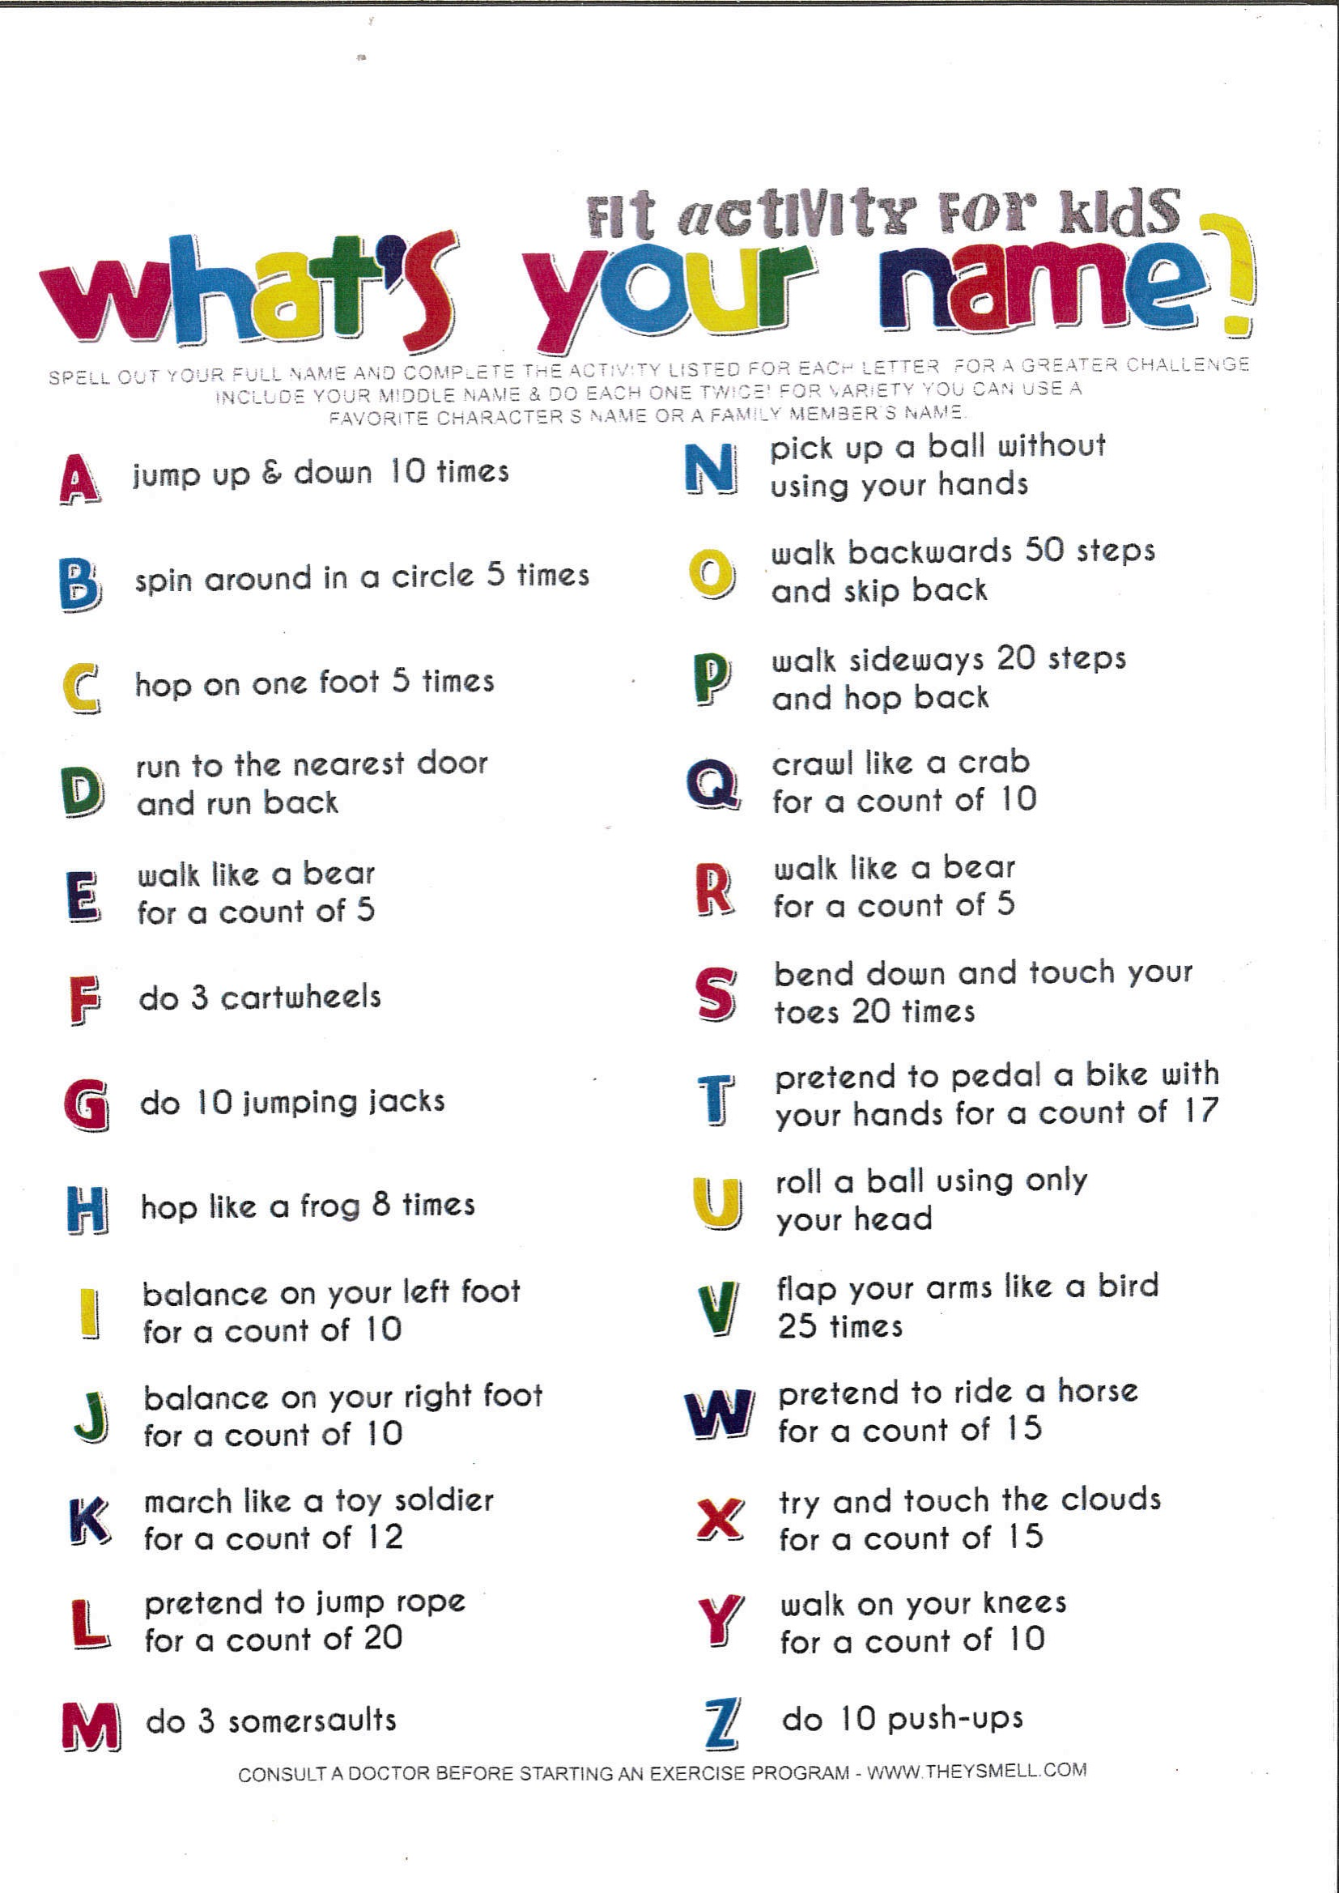
Use the following “What’s your name” sheet for the Name Game brain brake and feel free to come up with different actions for letters too .

